Subway Project Log

Project contributors: Gavin Burris, William Denney, and Brent Anderson.

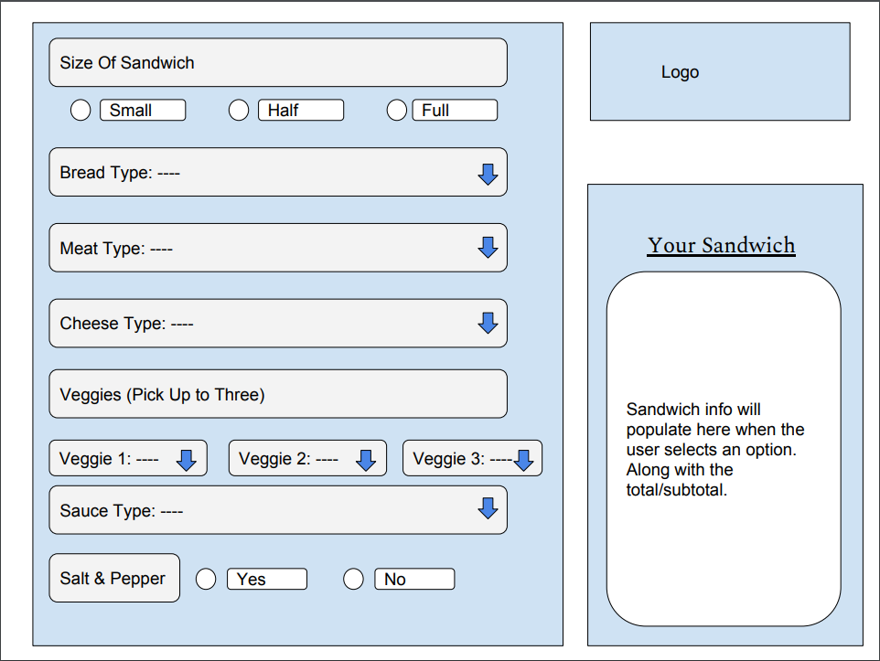

4/10/19

Meeting:

Discussion topics:  
-Gavin presented a wireframe for the layout of our sandwich building application. The wireframe was   
emailed to the group.  
-Work breakdown  
Brent and William will work on GUI  
Gavin will work on back end  
  
Action Items:  
-Brent and William  
Prepare samples of GUI components. Samples should include: TextField, TextArea, Radio Buttons,   
Dropdown, Inserting and Image.   
- Gavin  
Research approach for back end/data structure for processing selections and displaying order summary.   
  
Next meeting: Wednesday, 4/17/19 @ 4:30 PM

4/17/19

Brent provided version 1 GUI for project.

4/22/19

Project issue encountered: Main class was added to project.

4/23/19

William built upon V1 GUI and produced V2 GUI, which we added/revised in out repository.

4/24/19

Gavin started and finished the backend actions (listeners for property values) for the “Your Sandwich” option. He also updated the comments and some GUI components.

4/25/19

Brent presented V1 of complied the Project Log and asked William and Gavin for one last look over.

4/26/19

William, Brent, and Gavin all agree the project meets the requirements and are submitting the project.